Project Specification Document

Confidential – Not for Open Circulation

# Document Purpose

The purpose of this document is to be a single source of truth for the **Ejari** project being built by Builder.ai for **requirements / scope specification**.

All questions related to spec will be put as comments, and as they are answered they will be added to the document.

This word document will live as a Google Doc.

| **Kick-Off call held on:** | 12 March 2023 |
| --- | --- |
| **List of Attendees:** | Client:  Ejari |
| Builder.ai:  Thuy Phamova (Productologist)  Divjot Kaur Bawa (Account Manager) |
| **Build Card** | Account: yazeed@ejari.sa |
| **Design Board** | Prototype has been sent to Builder.ai (Divjot) |
| **Billing Currency** | Saudi Riyal (SAR) |

Project Overview

## Target Industry

Financing / Real-Estate

## Mission

The goal of Ejari is to provide monthly payments to tenants that are seeking to convert their single yearly lump-sum rent payment into more manageable monthly instalments. The project will incorporate two business models that will be described and has been explained in multiple calls between Ejari & Builder.ai’s team.

## Product Vision

To offer a rent now, pay later solution.

## What will an app user achieve when using this product?

1. Create an account with your ID or phone number to link with government platforms.
2. Upload your rental contract.
3. Apply for financing and receive the best possible rate from different banks/financing companies.
4. Make payments through the application.

| **General Questions** | **Y/N** | **Comments** |
| --- | --- | --- |
| **Will the product be monetized?** | ☒Y | Charging banks a fee by providing customers  Charging tenants a fee for providing the service |
| **Payment gateway needed?** | ☒ Yes | Hyperpay |
| **Multi-Currency?** | ☒ No | No other currencies than SAR. |
| **Notifications (push, email) or any specific reports needed?** | ☒ Yes   ☐ No | * sms * in-app and push (later phase - not initial) |
| **Any predefined design, colour scheme, logo?** | ☒ Yes | Yes |
| **Integration with any existing tool/application?** | ☒ Yes | Would require   1. Payment gateway 2. Government API’s 3. Simah (Saudi Credit Bureau) 4. Banks & Financial Institutions |
| **Existing website or application to refer to?** | ☒ Yes | Provided via Figma and a URL |
| **Multi-Lingual?** | ☐ No | English & Arabic, But english only in the initial stage MVP stage |

## Stakeholders

Identify the product’s actors

| **What type of users will be on the platform?**  *Below are personas and how they will use the product* | |
| --- | --- |
| **End users**:  Users will be able to do the following:  Sign up with phone number  Enter profile information  Upload rent contract  Choose rent payment offers  Pay monthly instalments of their yearly rent  Admin capabilities will be covered in the admin console. | |
| **Where are the target users located?** | |
| Target: Saudi  App store countries: Initially, KSA and GCC. (We want it available in the US since investors could be using a US app store account) | |
| **Any other information / General comments** | |
|  | |

Functional Overview

## Deliverables

Android, iOS

# Functionalities in Scope

*High level functionalities (group of features) that the product / platform will include for this project.*

#### Type of Users

Users:

* Type 1: End-User
* Type 2: Admin

#### Features

| **#** | **Features** | **Functionality Description** | **Users**  (who is this for) | **Build Card (BC) Status** |
| --- | --- | --- | --- | --- |
| 1 | Splash screen | “The first screen a user sees when opening the product. It reassures them that it's launching. In most cases, this would be a company logo and loading symbol”  This screen shall show the Ejari logo as the app loads. | All | In BC |
| 2 | Signup / Login | “Users sign up for your product using their name, email, and password. They can then use these details to log in. Users can also reset passwords through the forgot password function.”  Users shall signup using their phone number  The sign up page should also include all the user parameters which include:   * Salary (From Nafith) (API integration) * Age (from Nafith) * Monthly obligations * Yearly rent * Address (From Nafith) * Marital Status (From Nafith) * Number of dependants * Employer (From Nafith) | End-User | In BC |
| 3 | Admin Console | This page will be used for the application admin to keep track of the end-users application process, status, profile information, instalment information, history, and all the related information to his issued loan. The admin console should be able to view, edit, and override anything related to the customer journey. | Admin | In BC |
| 4 | Download | This function will be used by admin to download rent contracts uploaded by users by the admin. | Admin | In BC |
| 5 | API Integration | As part of the first build, there will be only one API integration (additional API integration are additional connections hence features to add on).  Client to confirm the API integration  Our application will have multiple API integrations with different government entities & financial institutions. Which will be the following:   * Elm & SDAIA (Government end-user information) * Ministry of Justice (Not confirmed yet) * Contracts.sa (Not confirmed yet) * SIMAH (End-user credit score) - will be used as needed * Unifonic (SMS) * Financial Institutions & Banks | Admin | In BC |
| 6 | Phone Login | Users can login using their phone number. No need to manage usernames or passwords.  Steps to Sign Up:   * First Sign up Enter phone number Get OTP from Nafith Enter OTP Phone number is verified through Abshir/Nafith/Elm API Profile information is pulled from that API and stored internally * Every following login will have the same flow Following log ins will not require Nafith API only an OTP through an SMS gateway Phone Login   Third Party Provider: Unifonic | User |  |
| 7 | Phone Verification | Send a verification code to a user's phone before they can create an account/login. Adds an extra layer of security, and the phone number can be another way to communicate.  Phone will be verified through Elm.  **3rd Party Service: Elm**  Third Party Provider: Unifonic | User | In BC |
| 8 | File Attachment | Upon the kickoff of submitting the user’s application the user will need to upload his/her rent contract as a part of the information used to get offerres for them. | Users | In BC |
| 9 | Settings | A list of common settings for the product.  Settings Menu:   * Profile Information * Account Information * Terms and Conditions (linking to a website) * Privacy Policy * Language Options * Contact Us | Users | In BC |
| 10 | Match Algorithm | Logic calculation behind eligibility:  Eligibility Amount = Customer Salary * 0.33 * 12 |  | In BC |
| 11 | Language Options | This will be used to support arabic language in addition to english language | Admin /User | In BC |
| 12 | Apple Pay Integration | This is to allow the user to pay his monthly instalments and initial contract cost using Apple Pay where the user could pay using different cards in his wallet which could be either Mada, Master Card, etc… | End-user | In BC |
| 13 | Contact Us | This page will be part of the End-users setting menu where he will have an option to contact us, we will display our contact info (Phone number, email, and eventually to be added a chat with representative in whatsapp feature) | End-user | In BC |
| 14 | Language Switch | This will enable end users and admin to switch between arabic and english. | end-user/admin | In BC |
| 15 | User Profile | Users can create and edit their basic profile information, including updating their profile. This information is visible to admin. It can also be used to manage users from the admin side.  This page will be used to reflect the information entered by the user in the multi page forms after launching the app. | Users/Admin | In BC |
| 16 | Multi Page Forms | This function is used to support the Sign up page where the user will fill his/her info on three pages as per the prototype and the signup function. Also, upon submitting the application the user will have a page to confirm/edit his/her information and another page to input the rent amount and upload the rent contract  Marital Status = Single, Married  Number of Dependants = 0, 1, 2, 3, 4, 5, More Employer = Text Box  Age = Number Box | user | In BC |
| 17 | Content Approval | This page will be part of the admin console where the application administrators will be able to approve the end-users applications and display them and override the information within it if required. In the initial stage this feature will be able to switch between the two business models when the users apply. (E.g. Manually enter the loan information and send it to the users, or send the user information to all the financial institutions and then send it back to the user. Also in the initial stage, this will always be manual where the admin will always approve the end-users applications. | Admin | In BC |
| 18 | Payments | * A system for accepting and processing debit payments and apple pay payments, with transaction histories and payment status. Users add their card details, giving them control and making purchases simpler and faster. * The idea is after accepting a rate, the user will be led to a payments page to pay the service/transaction page with the possibility to make future payments through the app. |  |  |
| 19 | Dashboard | This will be the main screen after the end-user has already signed and completed his application (Post-loan stage). This page will display his remaining balance, payment date, payment options and all the related screen buttons. This is clearly detailed within the prototype. | End-user | In BC |

## Change Log

| Date | Change | Notes | Who made the change |
| --- | --- | --- | --- |
|  | SMS feature to swap with Match algorithm |  |  |

# 

# Key Anticipated Challenges to Overcome

Risks foreseen that could impact the delivery of the product’s principal functions

| **#** | **Type of Challenge** | **Challenge Description** |
| --- | --- | --- |
| 1 | Technical | Integrating with different banks & financial institutions as well as government entities. |
| 2 | Functional | Since the business model has never been implemented before, we foresee challenges in fine-tuning the process till it is perfected. That is why we are starting with a testing phase. As well as having two business models that will impact the functions of the application slightly. |
| 3 | Communication |  |
| 4 | Other |  |

# Functionalities out of Scope (Please explain what this means?)

High level functionalities (group of features) that the product / platform will not include for this specific project

| **#** | **Out of Scope Functionality** | **Functionality Description** |
| --- | --- | --- |
| 1 |  |  |
| 2 |  |  |

# Working Assumption (Please explain what this means?)

Following the specification call, this section will highlight all structural assumptions that are made but which have an impact on the main functions or delivery of the product.

| **#** | **Assumption** | **To be verified by?** |
| --- | --- | --- |
| 1 | Technical |  |
| 2 | Functional |  |
| 3 | Time |  |
| 4 | Resources |  |

# App Store Preview Pages

Please use the industry standard by displaying the key screen with the app which are (Please note that the screenshots are from the fully built app):

* Pre-loan dashboard
* Choosing a financial institution
* Uploading the contract information screen
* Post-loan dashboard

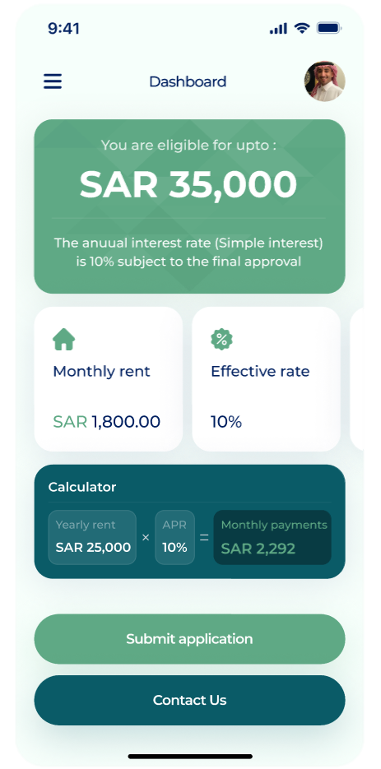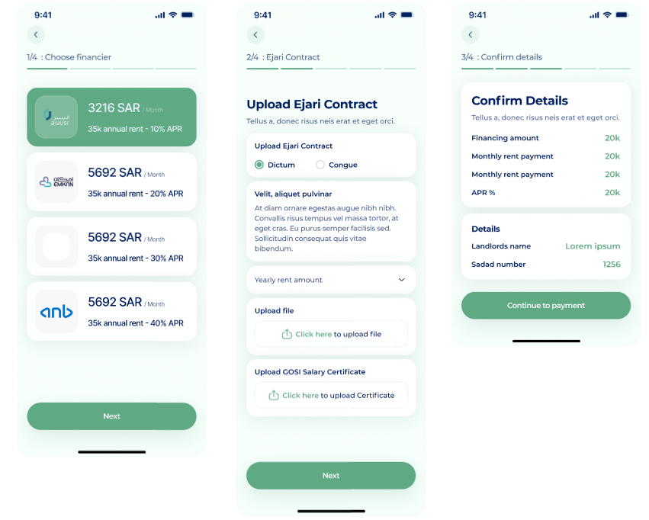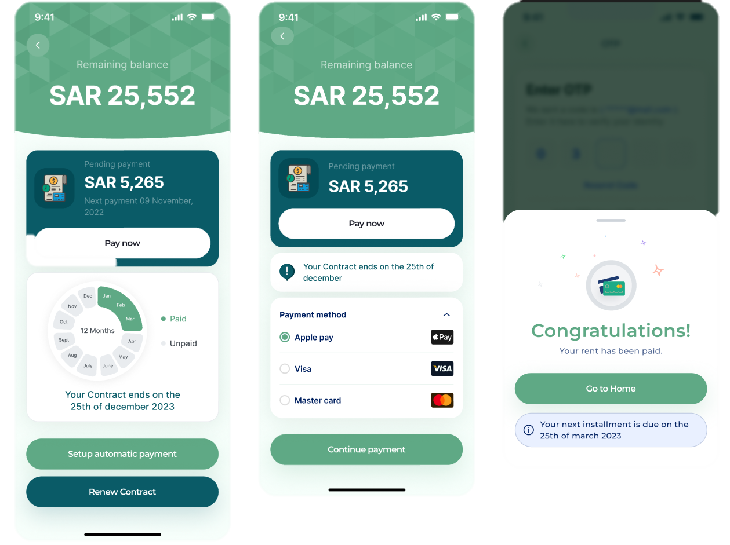

# Product Tutorials

**Welcome Page**

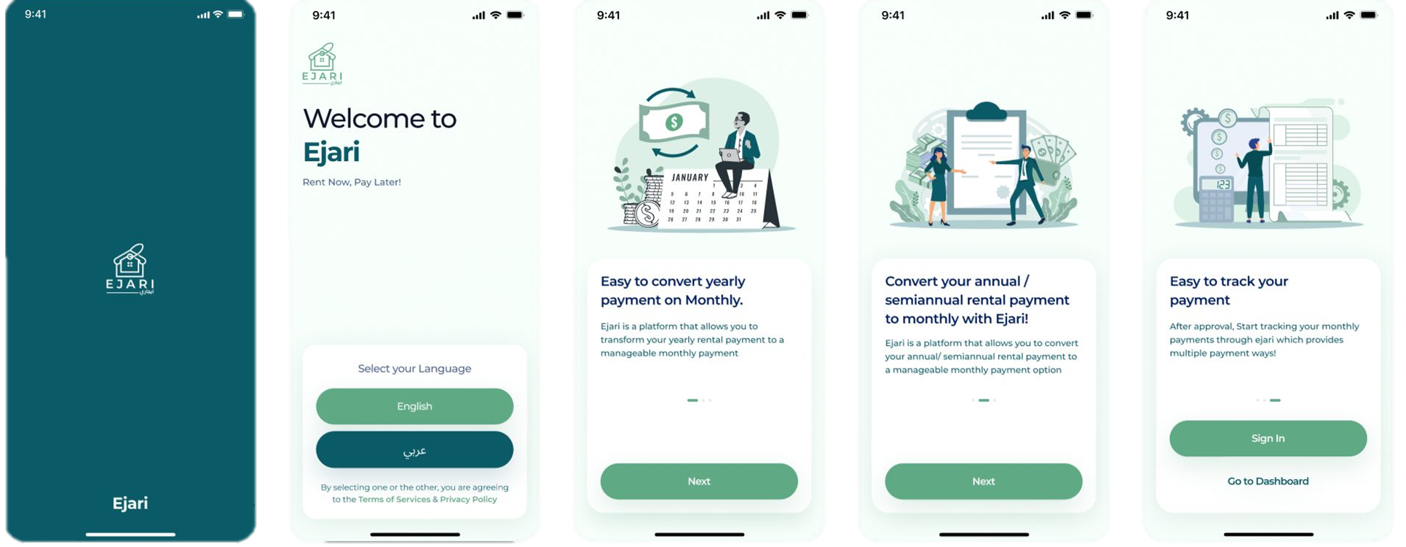

**Sign-up Page**

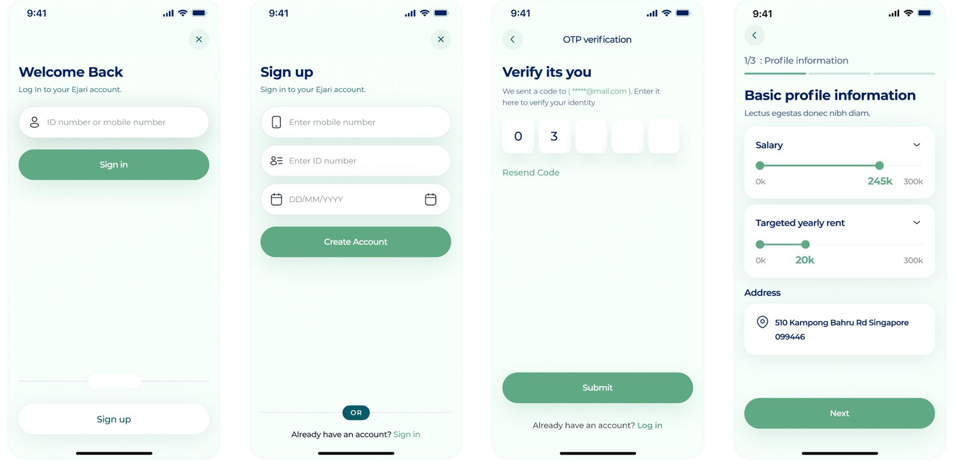

**Customer Info Entry Pag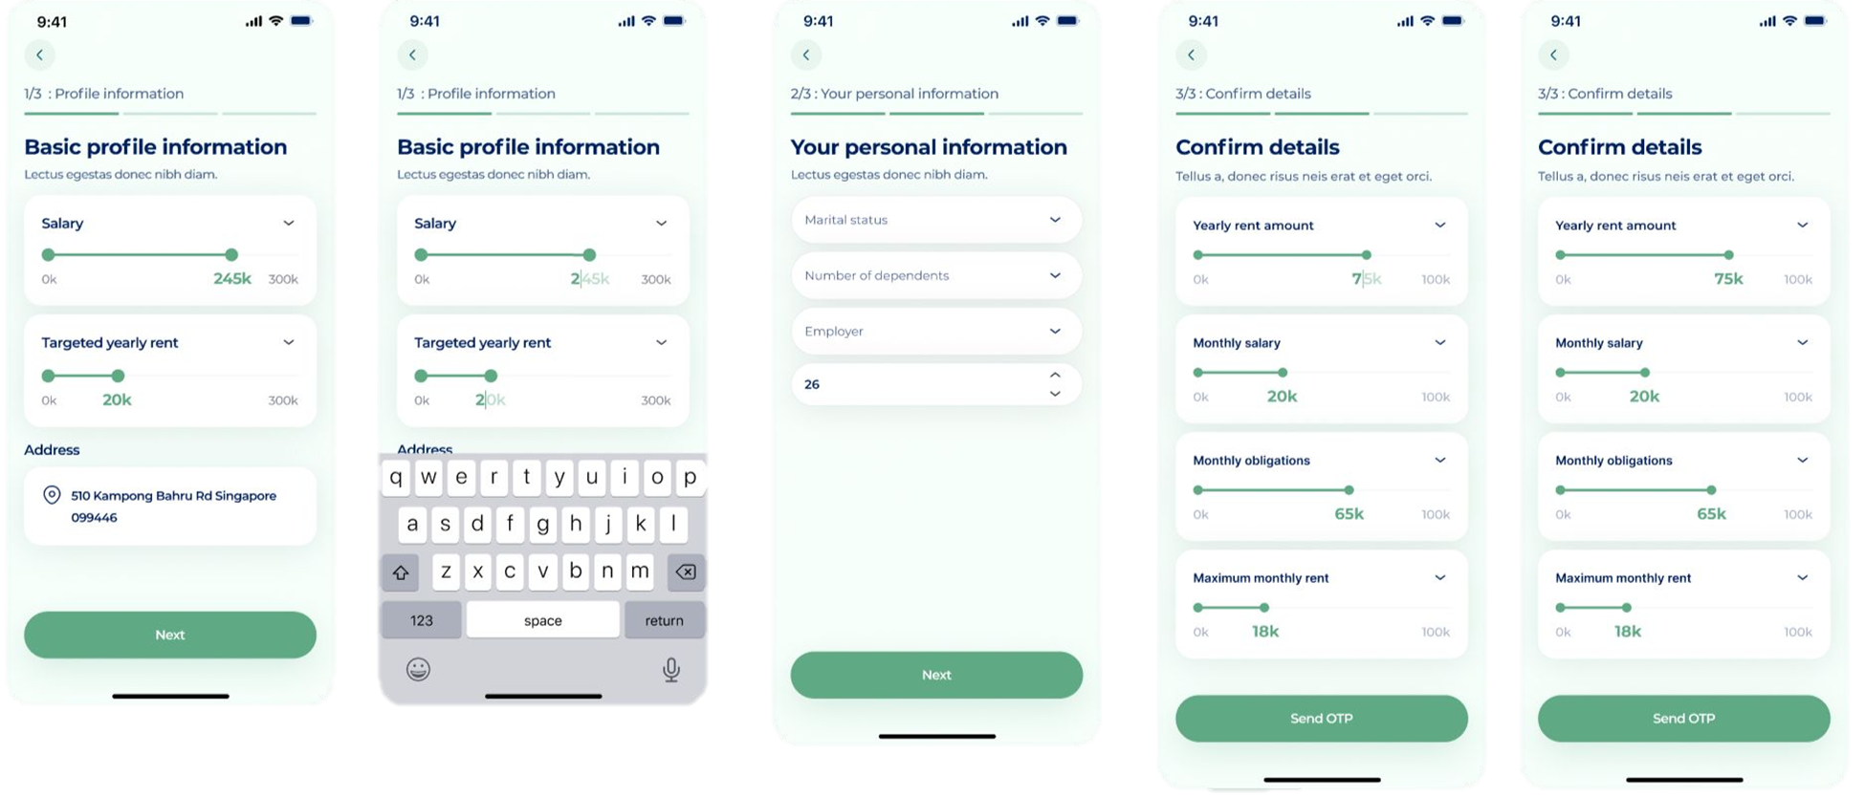Post Sign-up / Pre Application Page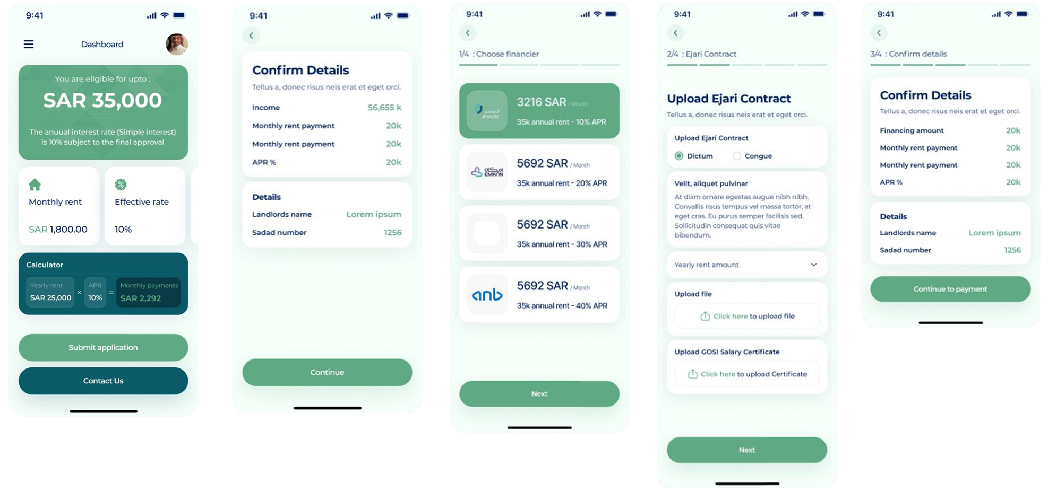Post Application**

